
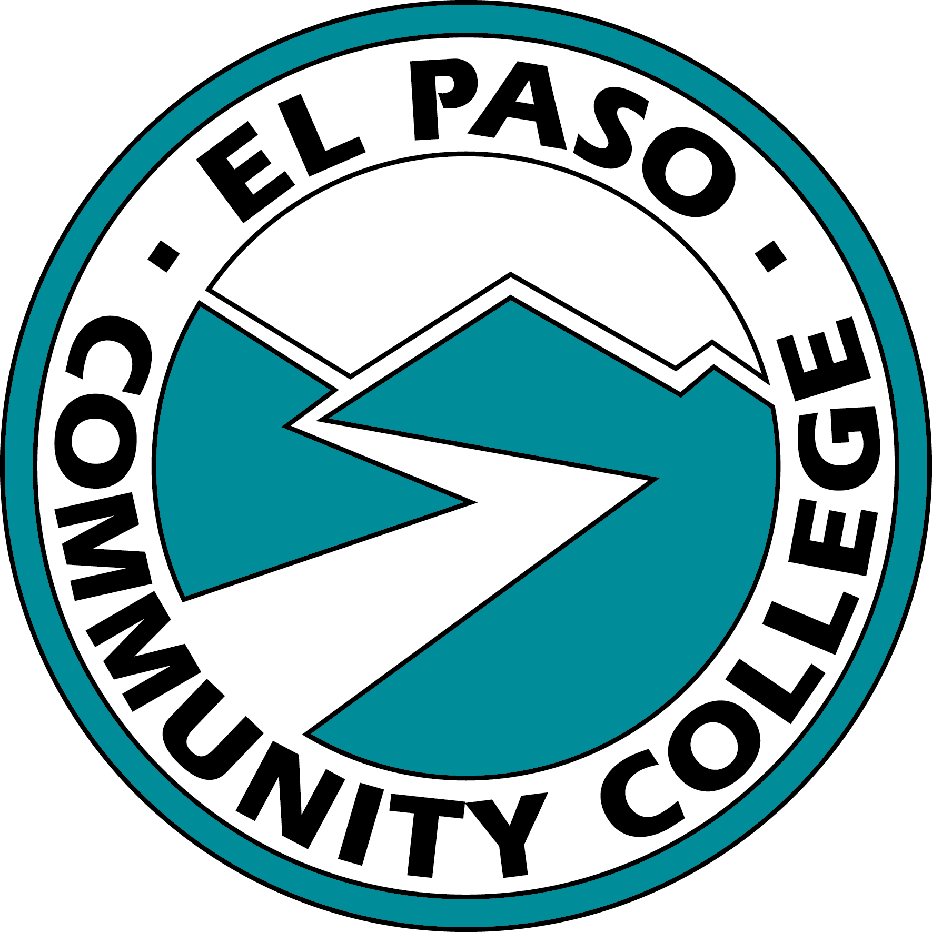

Tornillo Early College High School

Advisory Committee Meeting Minutes
Date 05/02/2024, 2:30 pm
Via Teams

Members Present: Mr. Jeff Brockhoff, Ms. Adriana Flores, Dr. Sourya Hajjar, Mr. Brian Kirby, Ms. Diana Medina, Mr. Alejandro Olvera, and Mrs. Elizabeth Otero

- Welcome

- Mr. Brockhoff advised the committee that Dean Badillo and Mr. Sandoval could not attend the meeting due to other obligations. Mr. Sandoval relayed through email that the site visit to Tornillo went well, and the 9th graders are achieving good results on the ELAR TSI through SureScore.

- February Minutes

  - The committee was provided with the February minutes.

- EPCC Updates

  - Dean Kirby offered continued support and assistance and reminded the committee of the upcoming graduation.

  - Dr. Hajjar offered her support and encouraged all to participate in the commencement ceremony.

- Tornillo Updates

  - Mr. Olvera advised EOC testing has ended. Also, three weeks ago, an outreach meeting was held on campus. Those in attendance were incoming freshmen and those interested in joining. Also, transcript audits are being conducted to ensure students are prepared to graduate.

  - Mrs. Otero said the Early College will attend the EPCC graduation ceremony. A luncheon is planned before graduation. During the luncheon, graduates will be presented with graduation stoles.

  - Mrs. Otero will have summer registration completed next week. Holding off on registration until next week allows some juniors the opportunity to pass the math TSI. Passing the TSI will enable those students to take MATH 1314.

  - Currently, eleven students are in the incoming 9th grade cohort. During Mr. Sandoval’s site visit, he showed what students to recruit by using the OBMs if there was little involvement or interest from the 8th graders. Mrs. Otero said they would like twenty-five students in the cohort; however, the 8th-grade class has forty-seven students, so it may be challenging to fill out entirely. Lastly, Mrs. Otero said the summer bridge camp is scheduled for the second week in June.

- Counselor’s Update

- Ms. Flores and Ms. Medina visited Tornillo High School before spring break to advise students.

- Dean Badillo and Ms. Savina, Assistant Vice President for Outreach and Student Success at UTEP, met to look at applicability numbers. It was found that in 2020, 60% of courses applied to specific majors. In 2023, it was found that only 38% of courses taken were applicable. Ms. Medina related that Dean Badillo has asked the counselors to monitor rosters to ensure classes taken apply to the students’ majors.

- Regarding applicability, Mrs. Otero raised a question about the Social and Behavioral Sciences block: What happens when two classes in the block are listed in the crosswalk? Ms. Medina advised the crosswalks are updated every five years. During the update, one of the courses should be removed.

- Ms. Medina related that Dean Badillo noticed that after COVID, students are taking more online courses and are not getting the college experience by attending classes on an EPCC campus. Dean Badillo encourages students to take courses on the EPCC campuses.

- Upcoming Events

  - The luncheon for graduates is to be held on Friday, May 10th.

  - The summer bridge camp is scheduled for the second week in June.

  - Mrs. Otero showed the graduation stoles to the committee.

- Other Items

  - None

- Next Meeting
  - The next meeting is scheduled for 2:30 p.m. on Tuesday, June 4th, 2024.

